**Developing Flow**

**Background:**

Developing flow is a fundamental concept in fluid mechanics, where the velocity profile of a fluid within a pipe transition from an unsteady or non-uniform state to a fully developed flow. When fluid enters a pipe, the velocity distribution is usually unsteady across the pipe cross-section. However, as the fluid moves through the pipe, the effects of viscosity near the pipe walls cause friction, slowing down the fluid close to the walls. This introduces a velocity gradient, and over a certain distance, the velocity profile gradually changes until it becomes steady i.e. fully developed flow. The flow is achieved by introducing a pressure gradient along the pipe.

**Geometry:**

Wall

Inlet

outlet

Wall

**Initial Condition:**

Inlet: Ux = 0; Uy = 0; P = P1(pressure at inlet)

Outlet: Ux = 0; Uy = 0; P = 0

Wall: Ux = 0; Uy = 0 (No-slip condition)

**Algorithm:**

SIMPLE algorithm

Convergence criteria = 10^-6

**Results:**

Time = 0.001s

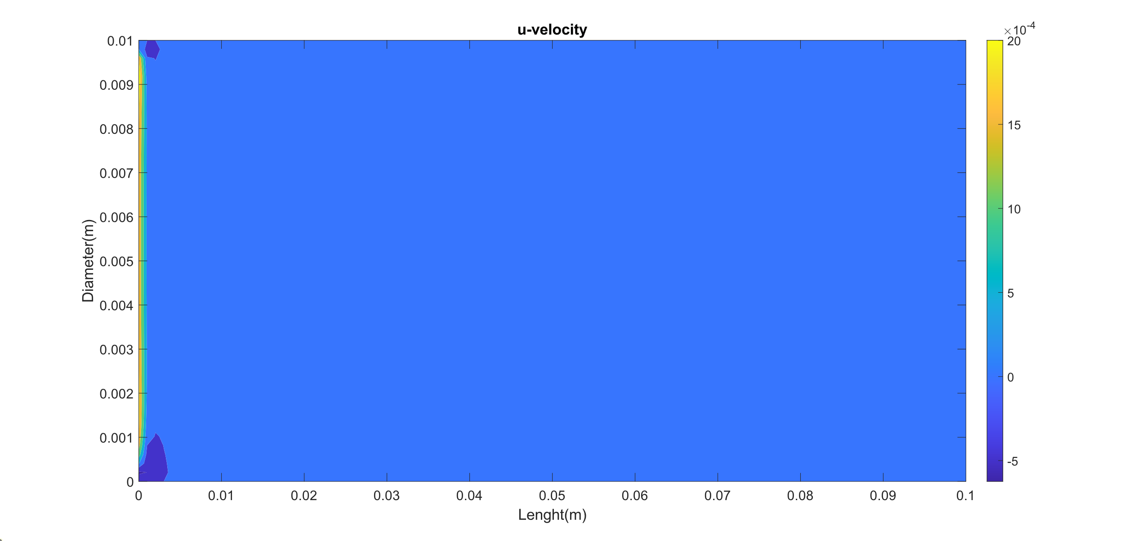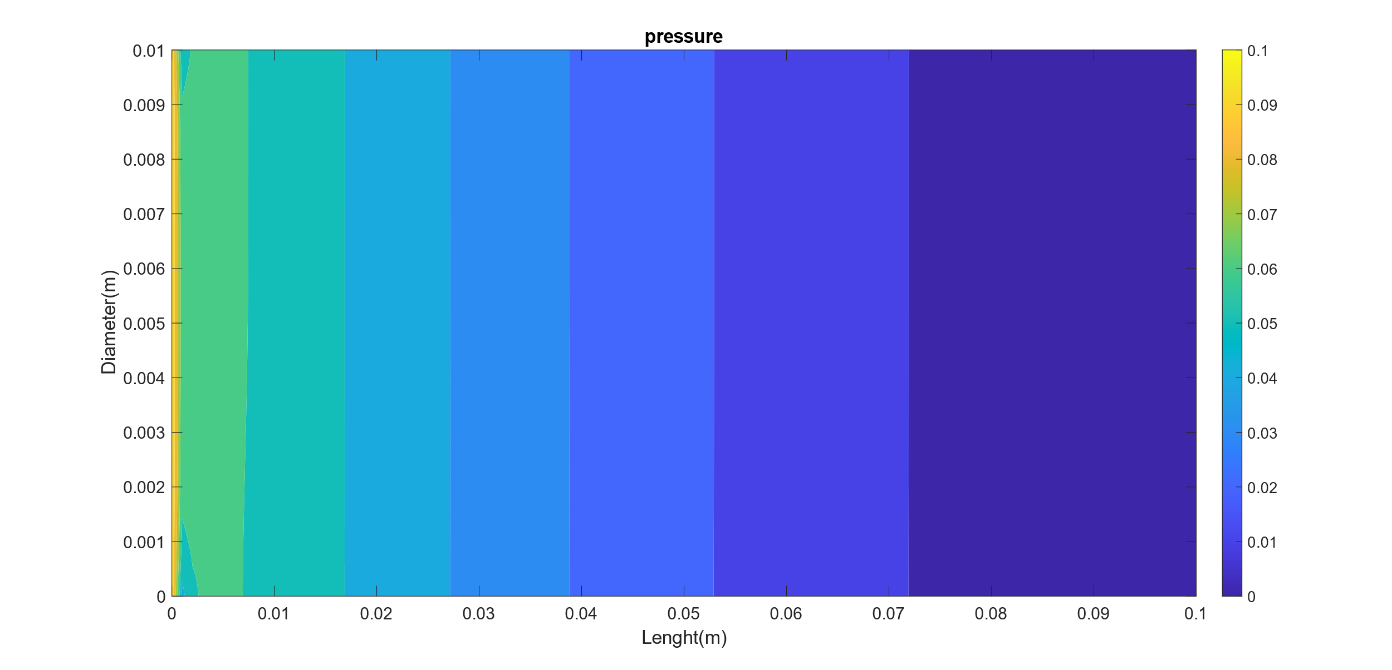

Time = 0.005s

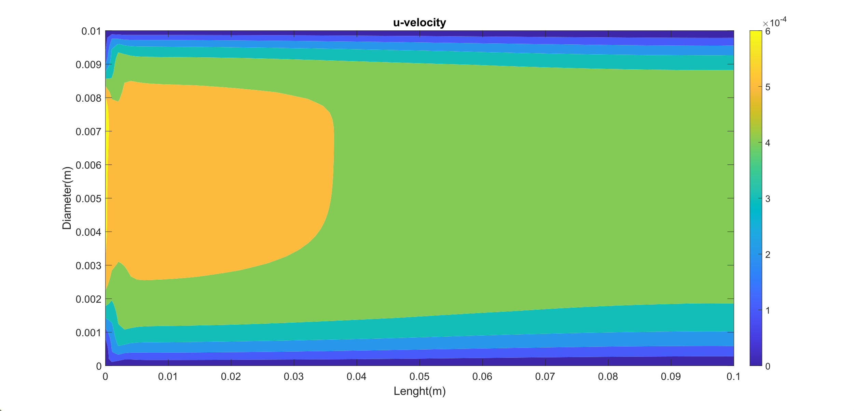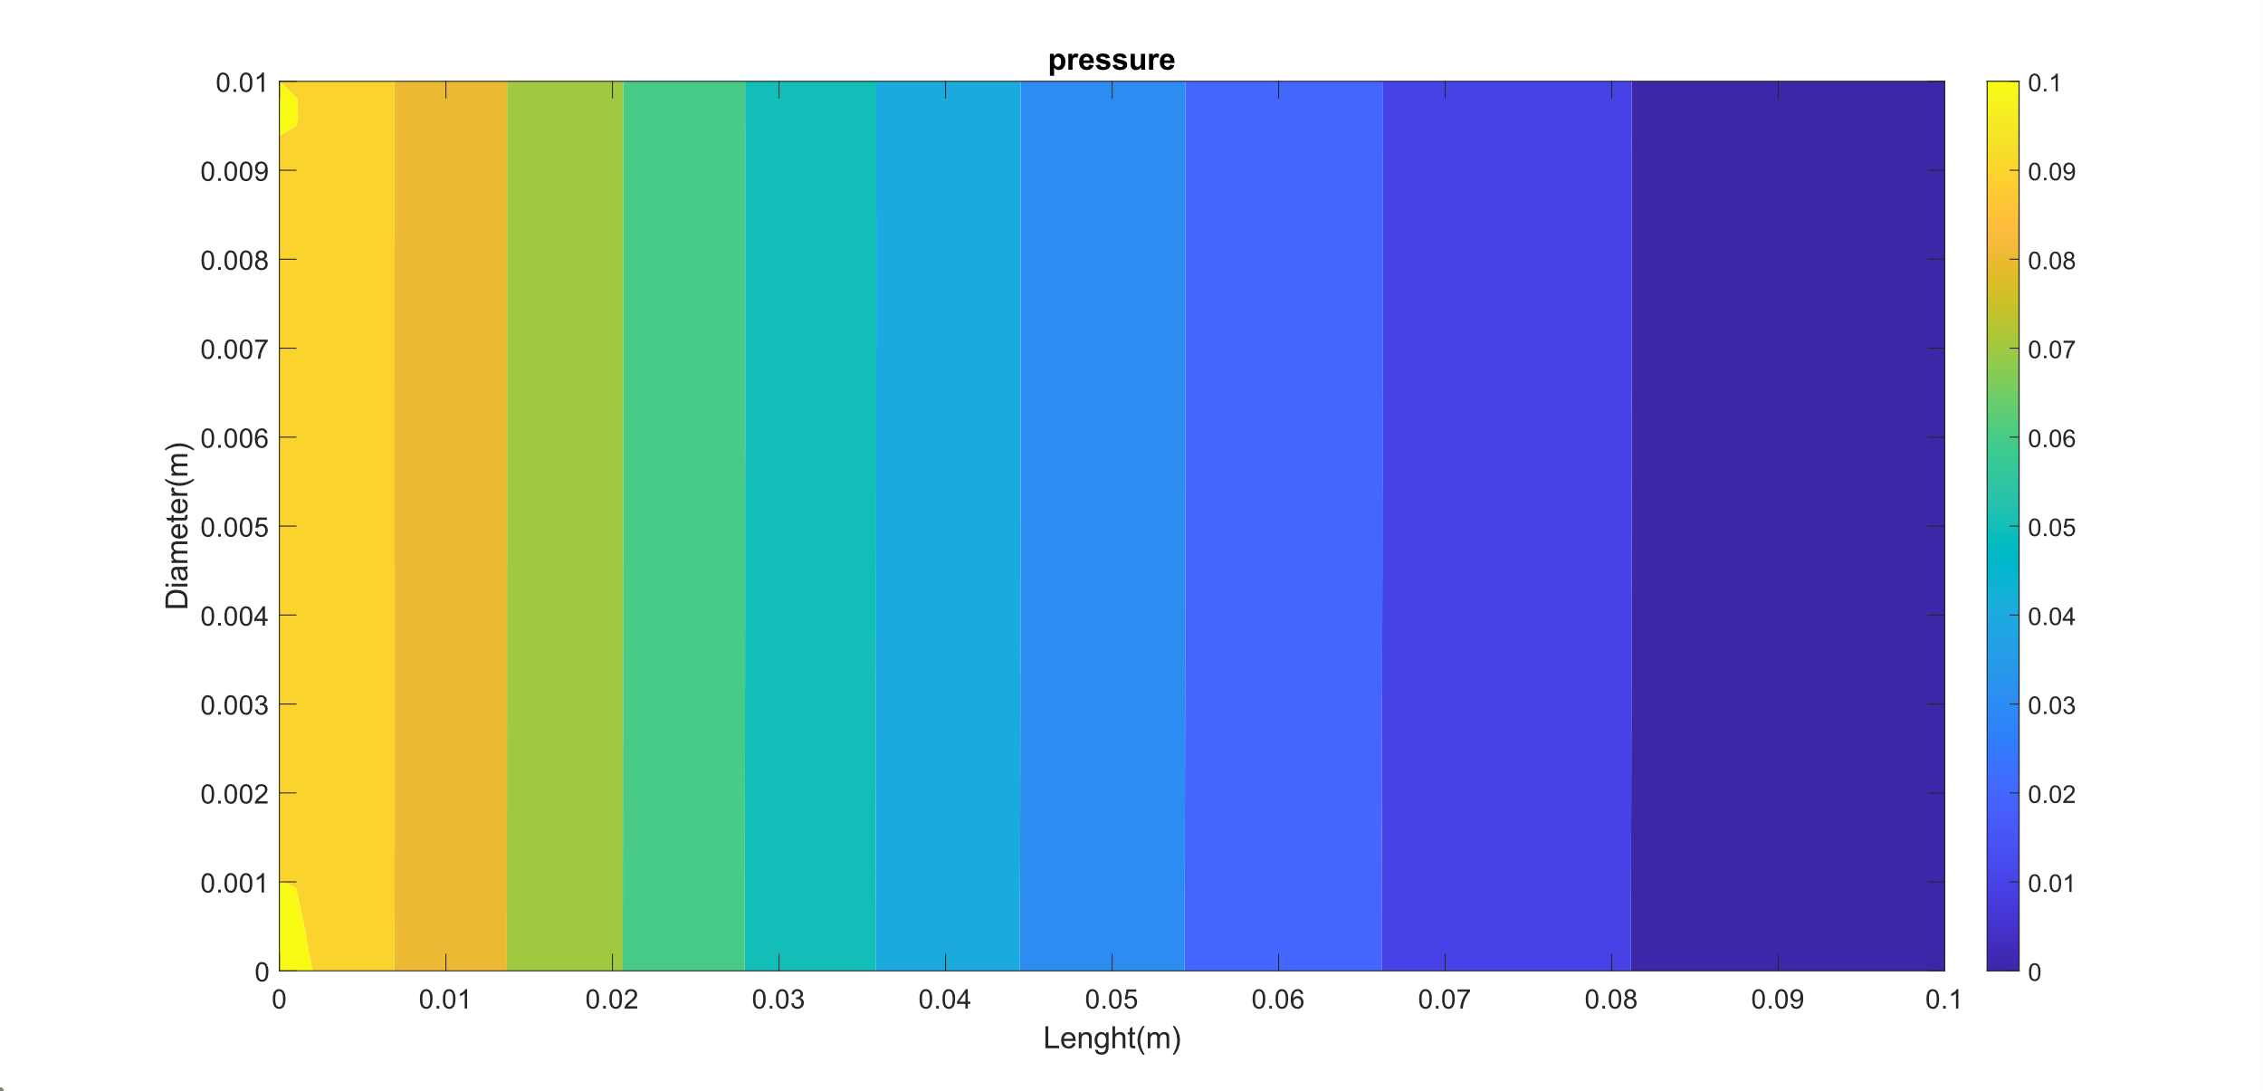

Time = 0.16s

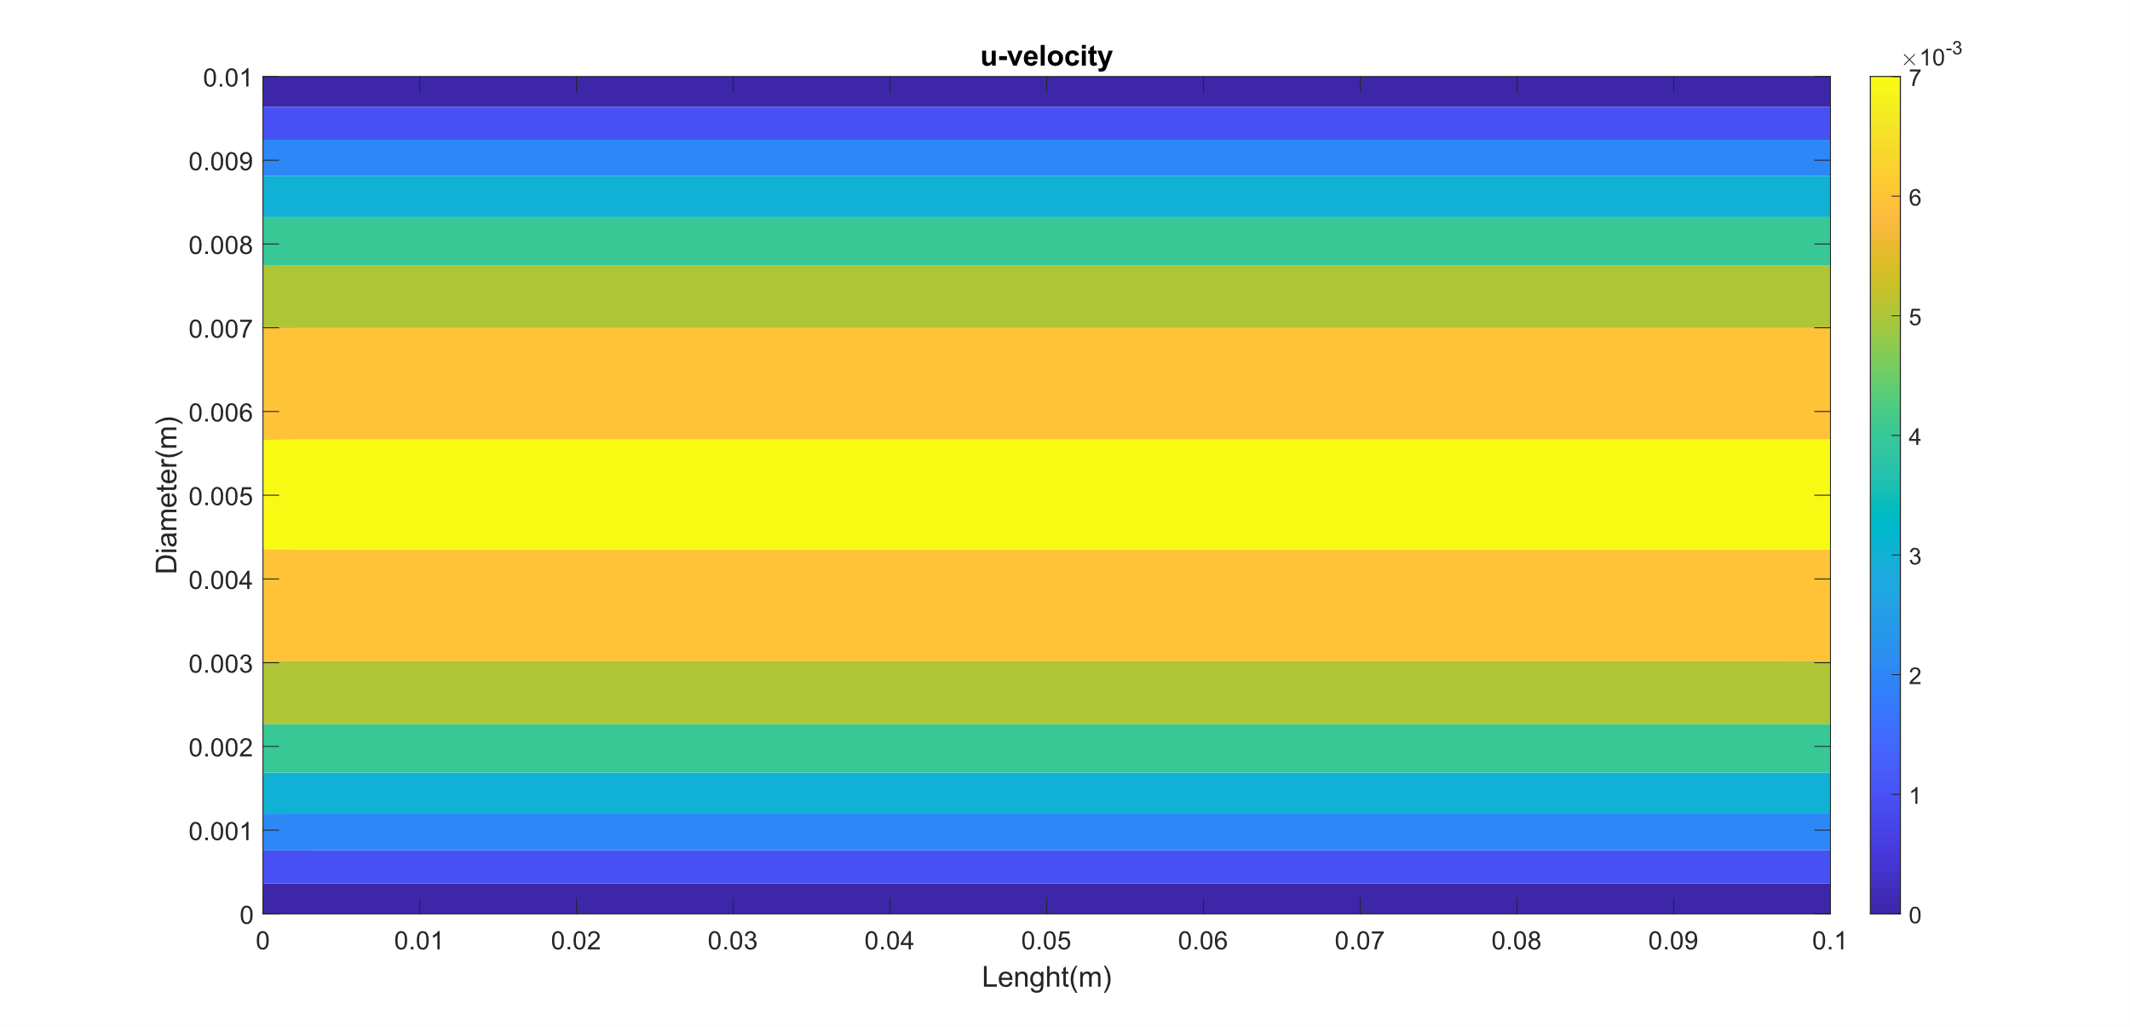 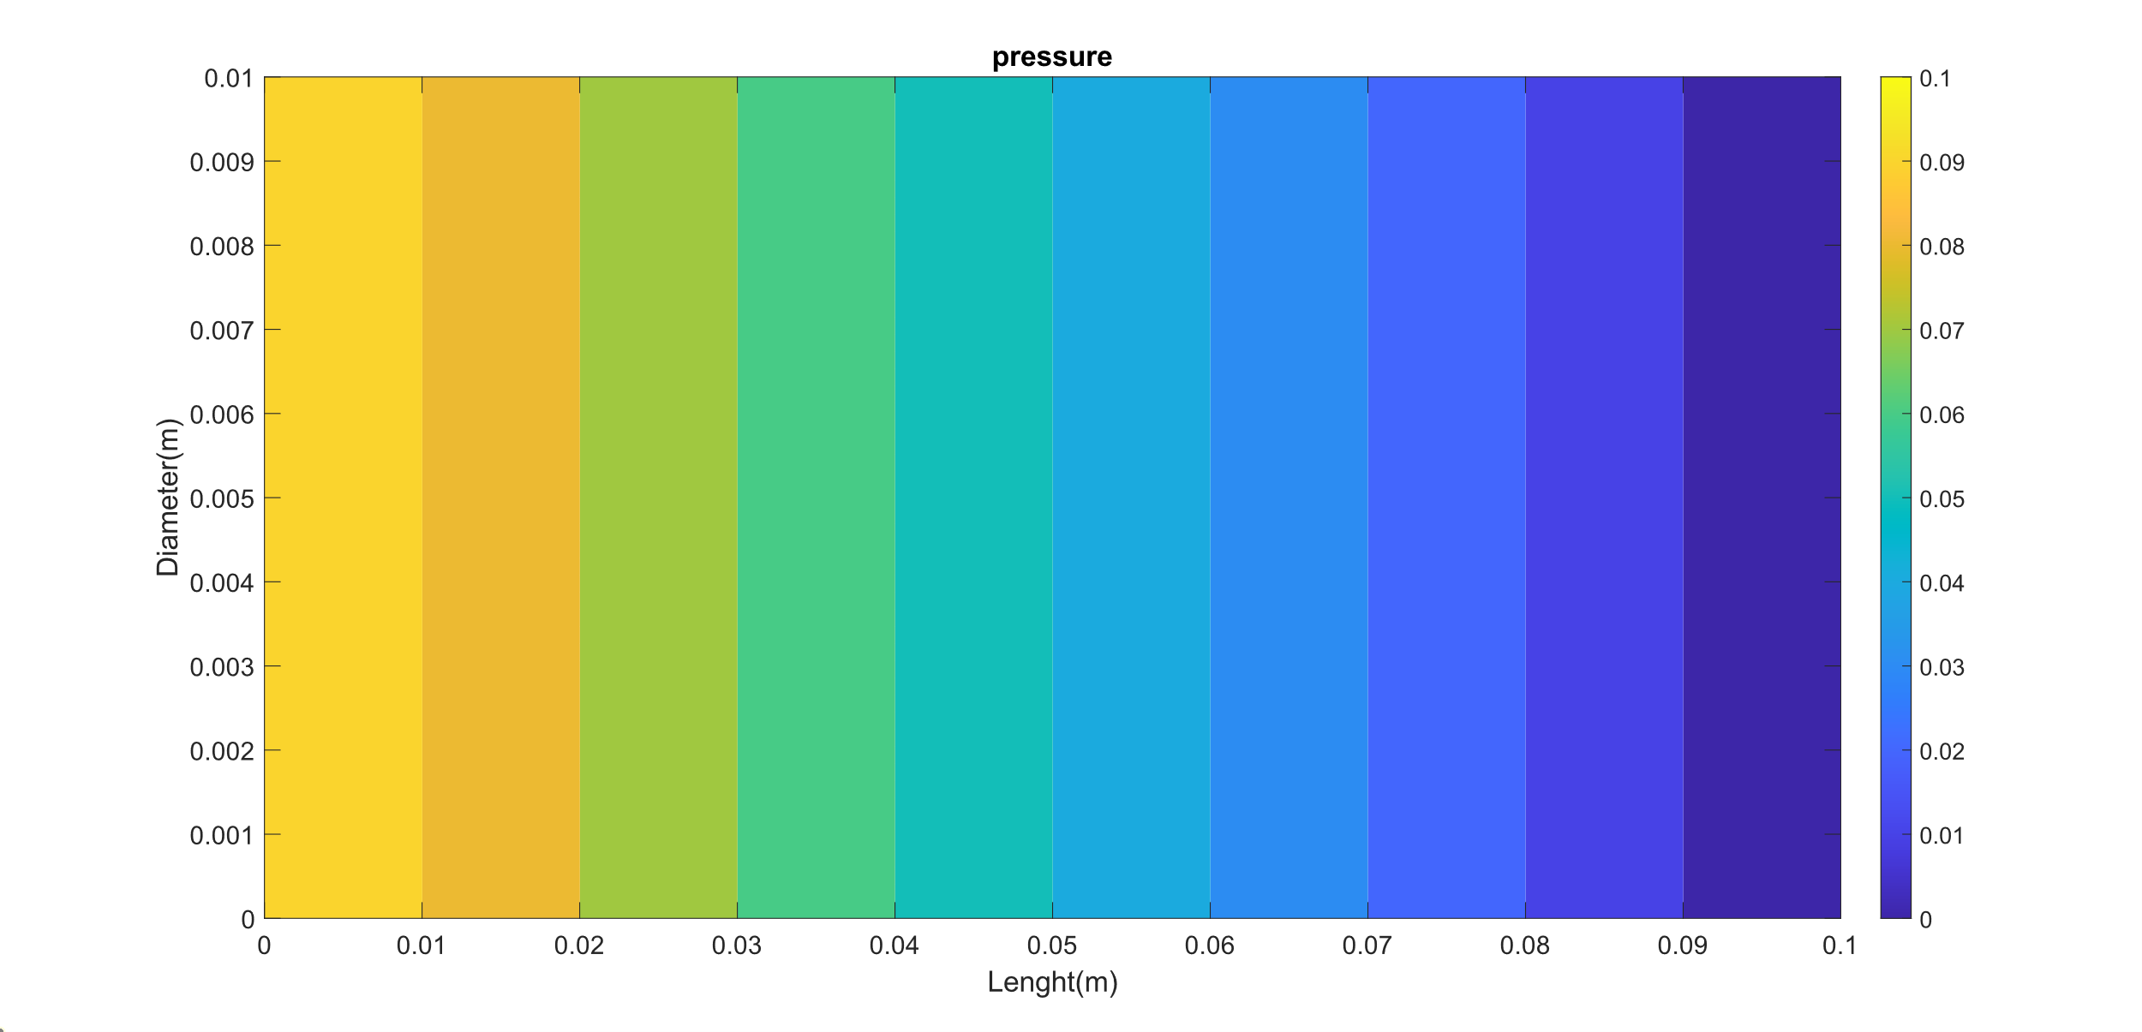

Steady state is achieved at 0.16s